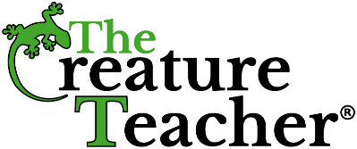

**The Creature Teacher Release Form**

Scholar Name: _______________________

Teacher Name: _______________________       Grade Level: ________________

Dear Parents,

  Your child will have the joy of experiencing  The Creature Teacher® at our school on _________________________________. The Creature Teacher® provides live animal educational programs for students of all ages. Their professional staff and instructors teach the state of Texas TEKS Standards incorporated with their love of exotic animals that will keep your student fully engaged and excited about learning! Due to limited space, this is only open to scholars and parent volunteers will not be needed for this experience. The Creature Teacher® allows scholars to touch the animals that are brought to the program.

Please fill out the parent permission slip form indicating whether you give your scholar permission to touch the animals or to abstain.

❏ I DO give permission for my scholar to touch the animals

❏ I do NOT give permission for my scholar to touch the animals

Permission slip is due back ________________________ to your teacher.

Parent Name : ___________________________________________________

Parent Signature: ________________________________________________